download file and upload to your arduino uno.

download the Keyboard firmware for the atmega16u2 (taken from

<http://mitchtech.net/arduino-usb-hid-keyboard/>

)

<https://github.com/coopermaa/USBKeyboard.git>

Download flip programmer

<https://www.microchip.com/developmenttools/ProductDetails/flip>

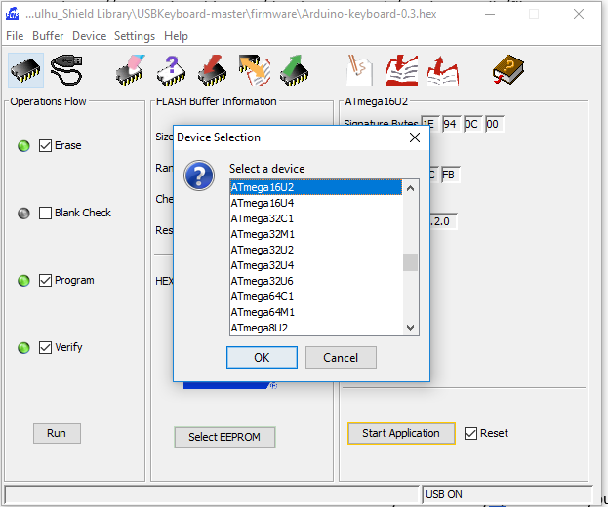

With arduino pluggedin, short these two pins together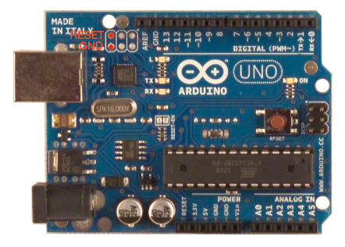

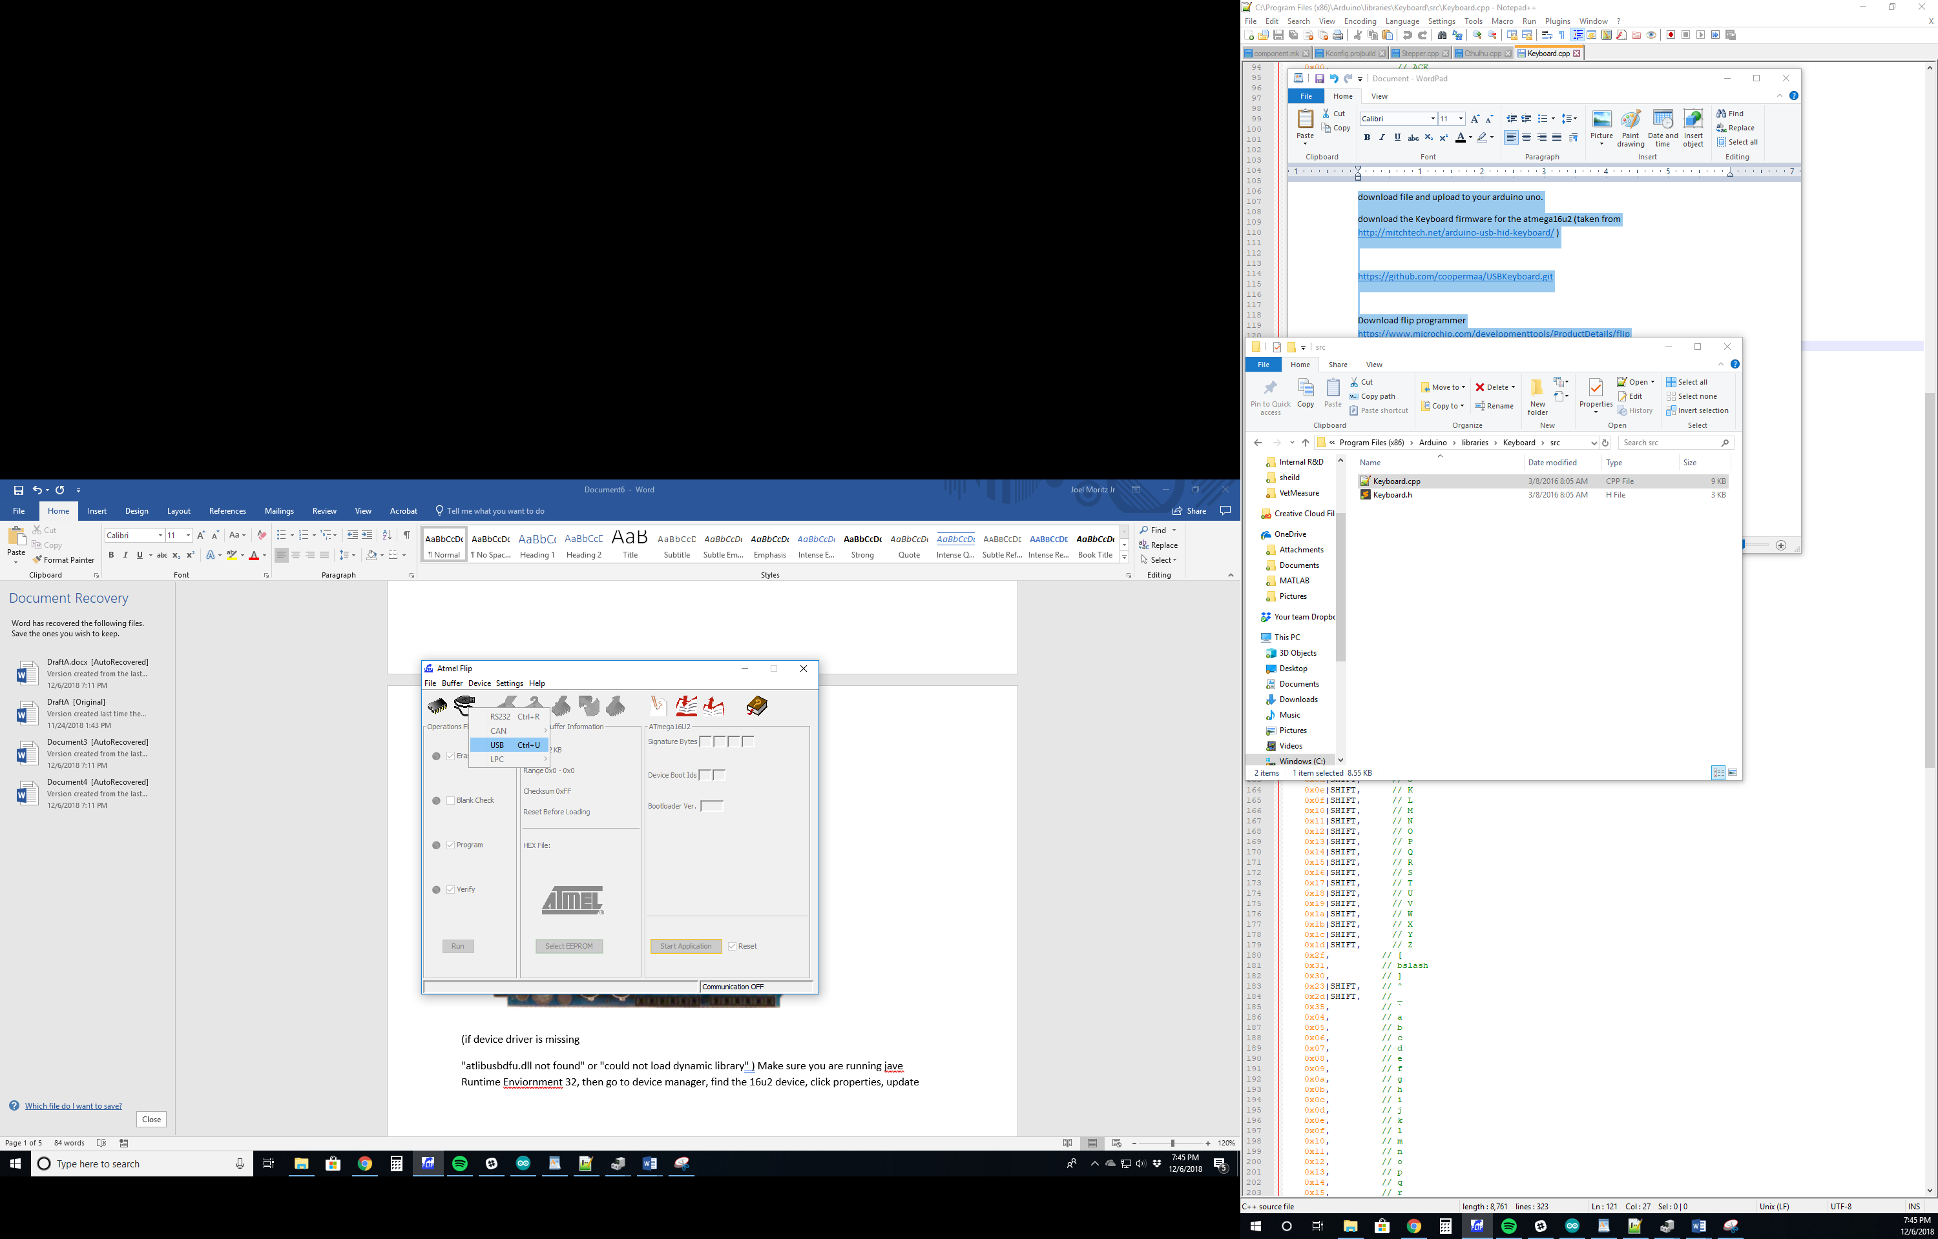

(If you can’t connect and get an error message see below ‘Update Driver’)

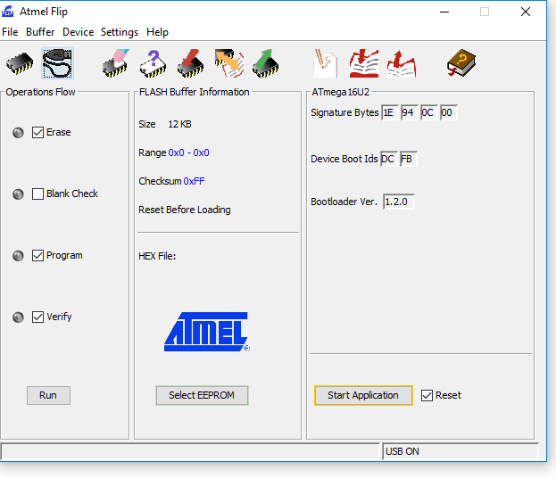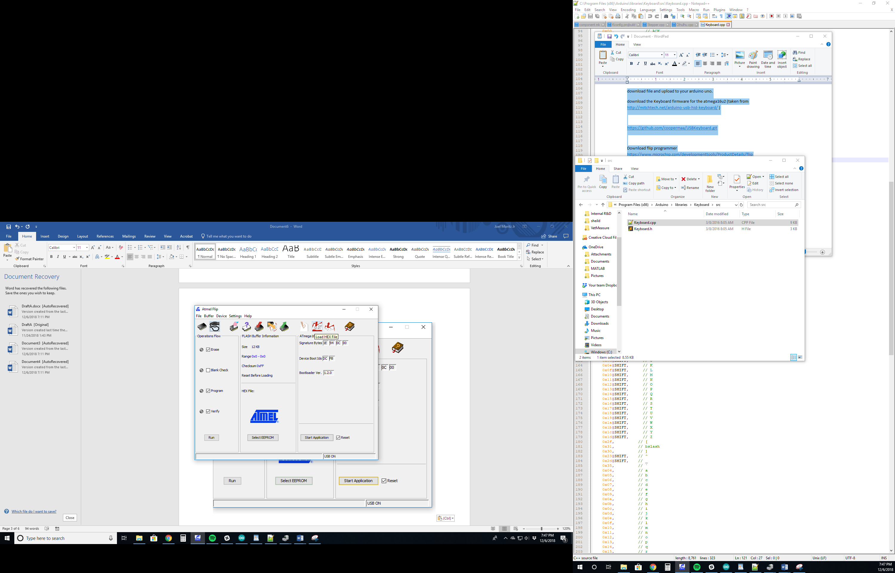

Navigate to the folder where you downloaded the keyboard firmware from github.

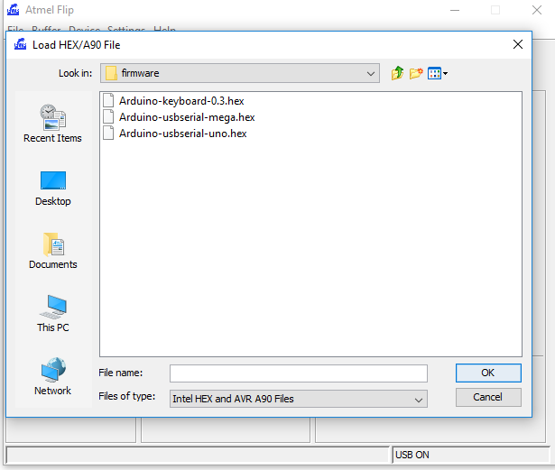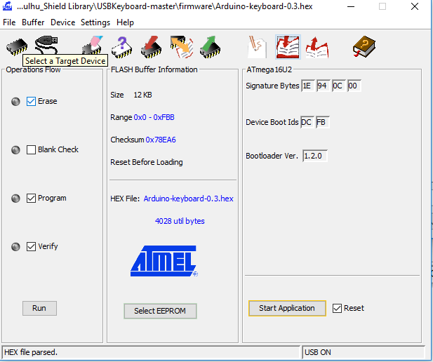

Click run , then unplug and replug in your arduino, when you plug it back in, your computer should recognize it as a standard keyboard.

**Note: if you want to reprogram your arduino, you must short the pins again, and flash Arduino-usdserial-uno.hex to your device, then unplug and plug it back in. If you want your device to be recognized as a keyboard again afterwards, you must reflash the keybard firmware.** 

**Update driver**

"atlibusbdfu.dll not found" or "could not load dynamic library" ) Make sure you are running jave Runtime Enviornment 32, then go to device manager, find the 16u2 device, click properties, update drivers, and navigate to and select the flip folder, then click update drivers. This should work. 